Find the Gap: The Lost-and-Lonely-BRATs’ Guide to Locating the University of Birmingham’s Track
The Track is cunningly hidden along Edgbaston Park Road, and only the most intrepid BRAT will choose the correct path to their running and/or athletics dream.
Or alternatively you can use this handy guide.
- The Track is on the same side of Edgbaston Park Road as King Edwards School and Winterbourne – which is the opposite side to the University Sport and Fitness and the main campus.
- It’s between Pritchatts Road and Somerset Road, nearer the later.
- It’s behind Priorsfield, so this is the best sign to look out for when you first arrive for your adventure.
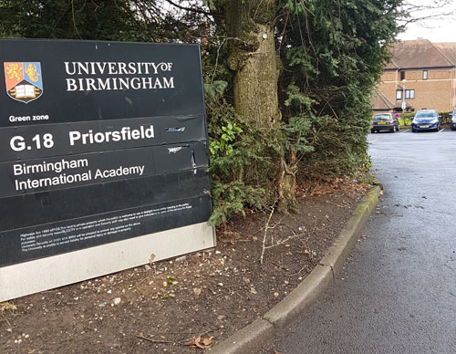
- But you can go in either of these entrances (Conference Park Hotel or Priorsfield)
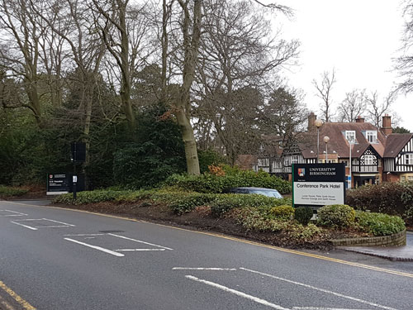
It’s possible to see the track as you come forward into the car park at the Priorsfield entrance. Enticing, huh?
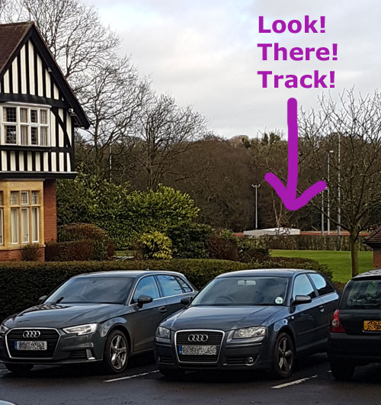
But how do you get there? So close, and yet so far…
The secret is to turn left through the car park and look for this unassuming gap in the wall. And go through it. Obvious, huh?
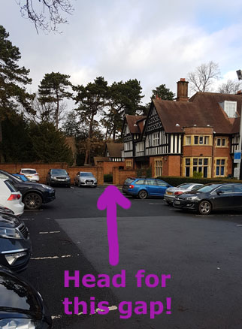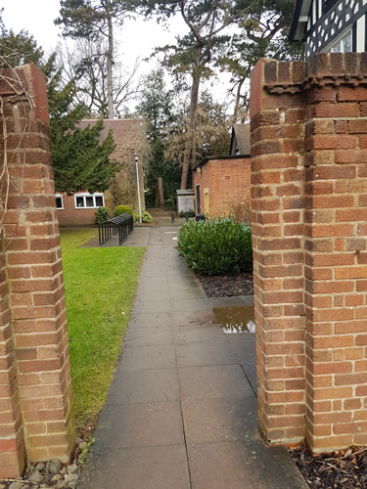
But wait, your quest is still not at an end, because after you go past the handy bike parking you need to turn right
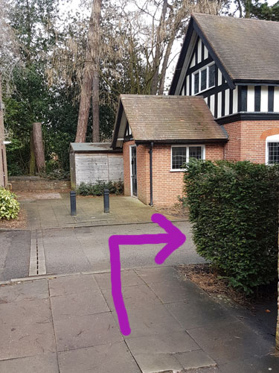
And head down by the side of this lovely building
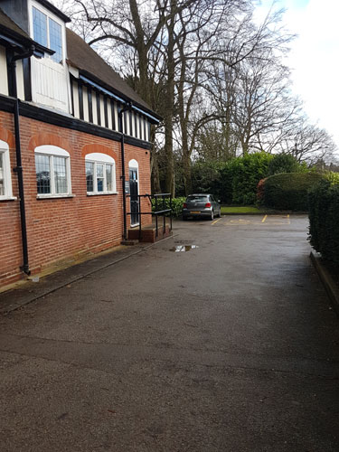
And then turn left at the end of it on to a path.
And then take the right hand fork. It looks kindda newer….
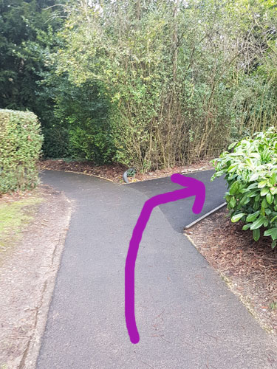
And after that you can’t really go so wrong. Unless you fall down the muddy bank.

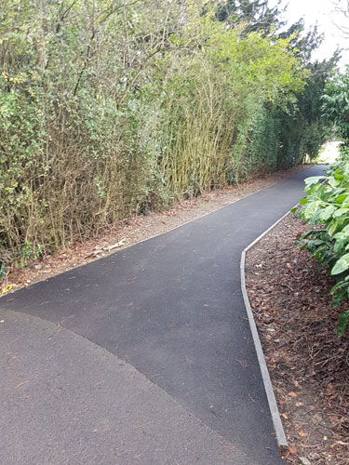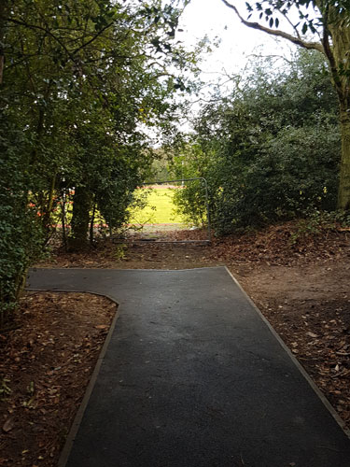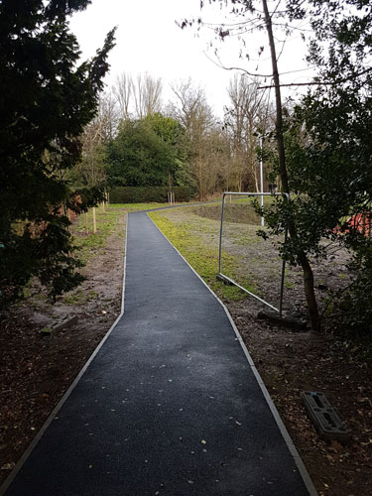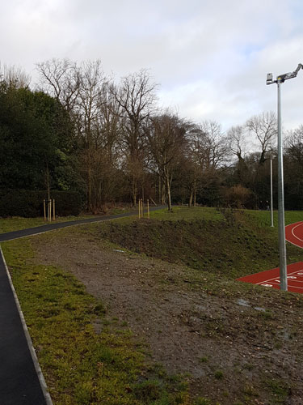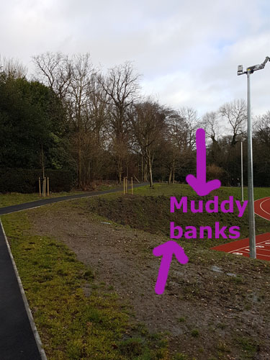
Keep following this path and you will finally reach the track.
All this gap and path nonsense takes a bit longer than you might think, so unless you want to do an extra high-speed rep before you start, maybe give yourself a few minutes!
